|  |
| --- |
| Repeat Project |
| 3D Pong: Technical Manual |
| Seamus O ‘ Neill: C0015683 |



|  |
| --- |
|  |

**Table of contents**

UML………………………………………………………………………………………………………………2

Third Party References…………………………………………………………………………………3

Declaration of originality………………………………………………………………………………4

UML Diagram

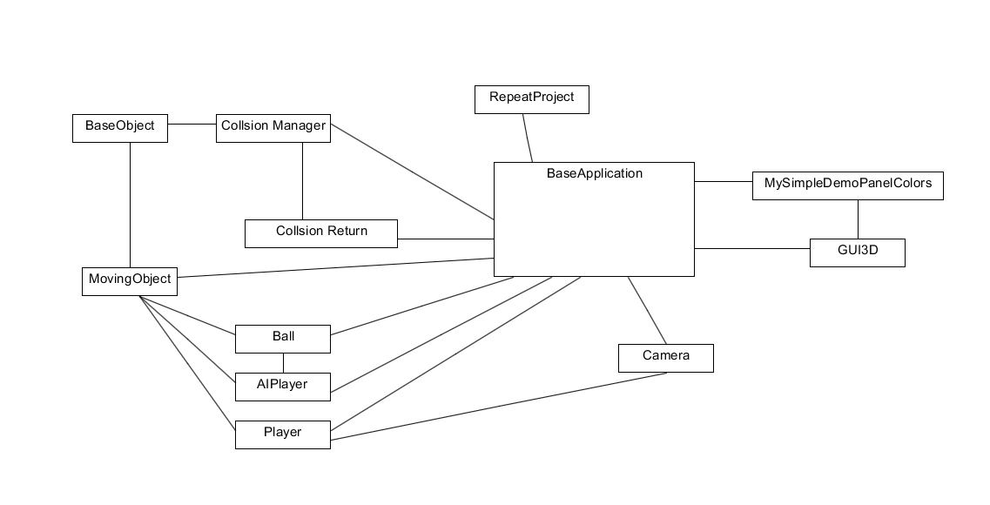

Third Party References

Pong

Pong was made in 1972 by Nolan Bushnell and Allan Alcorn. It is the property of Atari Inc.

Ragtime

Ragtime is from the “Don’t Starve Official Soundtrack” and I property of Klei Entertainment

<http://www.dontstarvegame.com/official-soundtrack>

FMOD

<http://www.fmod.org/download/>

GUI3D

<http://www.valentinfrechaud.fr/GuiWiki/index.php/Download>

DECLARATION

I declare that the work I am submitting for assessing by the Institute examiner(s) is entirely my own work, save for any portion(s) thereof where the author or source has been duly referenced and attributed.

I further state that I have read, and am familiar with, the Institute Examination and Assessment Regulations and that I am not, so far as I am aware, in breach of any of these regulations.

Student Name:………………….Student ID Number:………………

Course of Study:…………………………………………………………………..

SIGNED:_________________________________DATE:______________